**CCS Student named Ambassador for "Nothing Down" Organization**

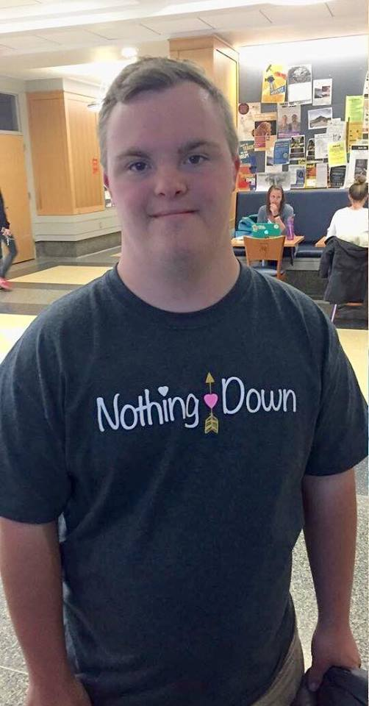

**David Heller, CCS Sophomore, is named the first Ambassador of the**

**"Nothing Down" Organization**

**(**[**www.NothingDown.org**](http://www.nothingdown.org/)**)**

**Click here for more information on this exciting honor:**

[**https://www.facebook.com/permalink.php?story_fbid=479053712304042&id=437232779819469**](https://www.facebook.com/permalink.php?story_fbid=479053712304042&id=437232779819469)