STUDENT LIFE BIOS 2017-2018

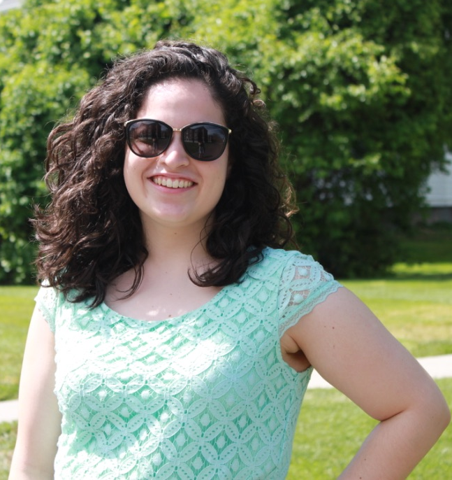
Meet Amanda Sarria

Amanda is TCNJ graduate student with a Bachelor’s Degree in Mathematics. She is currently working towards her Master’s Degree in Special Education. Amanda is the Student Life Mentor for five awesome Sophomores and Juniors: Alex, Courtney, Emily, Melissa, and Mike!

“I am very excited to start
my third year as a Student Life Mentor. I am looking forward to a year of learning new things, making memories, and having a lot of fun!” – Amanda

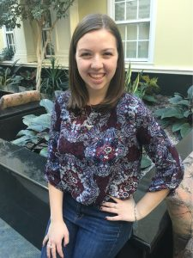
Meet Giulietta Flaherty

Giulietta is a junior psychology major at TCNJ. This is her first semester as a House Mentor Assistant.

“I did not know about the CCS program my freshman year, and I am so sad I missed out on a whole year of being a mentor!! I loved being an academic and vocational mentor my sophomore year, and I am excited to begin my journey as a student life mentor this year.” – Giulietta

Meet Jimmy Hunter

Jimmy is a TCNJ junior Self-Designed Speech Pathology Major. He is an Academic, Vocational, and Fitness mentor.

“I have been involved with the CCS Program since my freshman year. Some of the kindest and most genuine people I know are in the CCS Program, and I am proud and blessed to be able to call them my friends. Seeing a friendly face as I walk around campus or into a study lab is what I love about being a friend of the
CCS Program.” - Jimmy

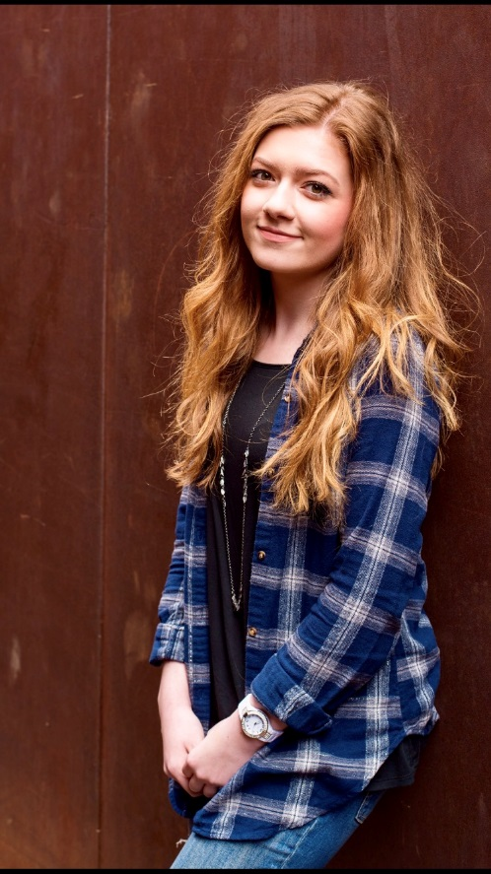
Meet Christina Wood
Christina is a TCNJ Psychology major and double minor in Deaf Studies and Communication Disorders. She is a new House Mentor Assistant this year!

"I have been heavily involved with CCS as both an academic and vocational mentor since my freshman year. Through mentorship, I've learned more than I ever have in a classroom, and made many incredible friends at the same time. I look forward to expanding my experience this year and creating a lot of memories with both the students and fellow student life mentors!"

Meet Emily DiRusso

Emily is a TCNJ senior working towards degrees in Special Education and Sociology. She is a House Mentor, and outside of her studies and working with CCS Emily is also a member of the Students for Disability Awareness club and Kappa Delta Pi Education Honor Society.

“I started working with the CCS program as a vocational and academic mentor my sophomore year, and I absolutely loved supporting the CCS students in those areas. My junior year I also supported in Student Life as a House Mentor Assistant, I am very excited to be a House Mentor this year! I look forward to supporting CCS students in learning independent living skills while also building more friendships with students in this role.”

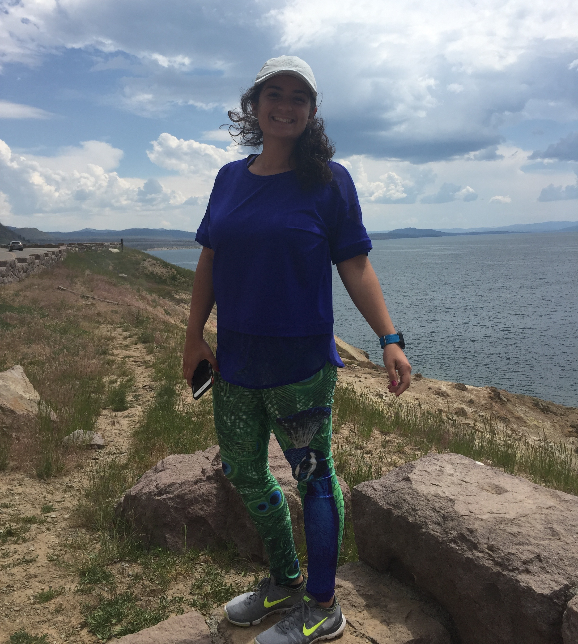
Meet Arianna Sirimis

Arianna is a TCNJ junior studying Special Education and i-STEM (with a specialization in Technology and Engineering).

“I have been working with the CCS Program since my freshman year as a volunteer in the study labs. Last year I had the privilege to be an in-class and practicum mentor. All of my experiences with CCS have been so great and I cannot wait to start this year as a House Mentor Assistant!”

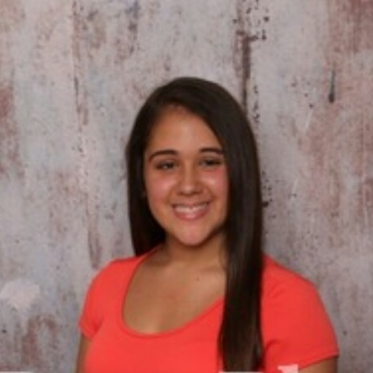
Meet Jess Naroden

Jess is a TCNJ undergraduate student working towards degrees in Elementary Special Education and iSTEM. She is a house mentor assistant.

“I have been involved with the CCS program since my first semester freshman year through my FSP where I was paired with a student. I instantly found my TCNJ family within this program and am very excited for the years to come! My college experience would not be the same without the friends that I have made here.” -Jess

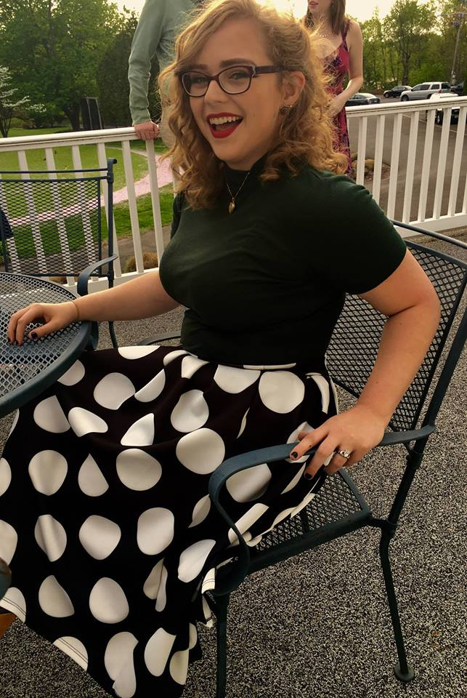
Meet Jess Soden

Jess is currently a T CNJ Senior working towards degrees in Special Education and English. She is a CCS Academic and Student Life Mentor.

“I have been served as an Academic, Vocational, and Social Mentor for CCS since my Sophomore year. Being a mentor has been one of the best experiences I've had at TCNJ. I am so excited for another year of learning and fun!"- Jess

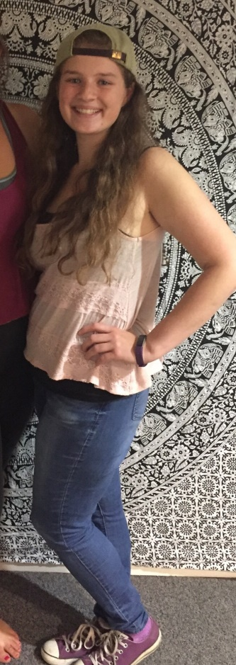
Meet Marcia Schleppy

Marcia is a TCNJ senior working towards her degrees in Special Education and Psychology as well as a middle school endorsement in math. She is the student life house mentor for five amazing sophomores and juniors, James, Kyle, John, Rachel and Danielle.
“I have been involved as an academic, social and vocational mentor with the CCS program for three years and last year I started my journey as a Student Life House Mentor and instantly loved it. Therefore, I am so excited to return for my senior year! I can’t wait to grow alongside my housemates and create lifelong memories. Looking forward to an amazing year!” –Marcia

Meet Abbi Anker

Abbi is a TCNJ graduate student working towards her Master’s Degree in Special Education. She is a CCS Student Life mentor for five students in an on-campus home.

“This will be my third year as a house mentor, and I can’t imagine spending my final year at TCNJ any other way. From supporting my housemates, I have become a more compassionate and confident person. I am looking forward to a memorable and exciting year.”
–Abbi

Meet Avery Madden!

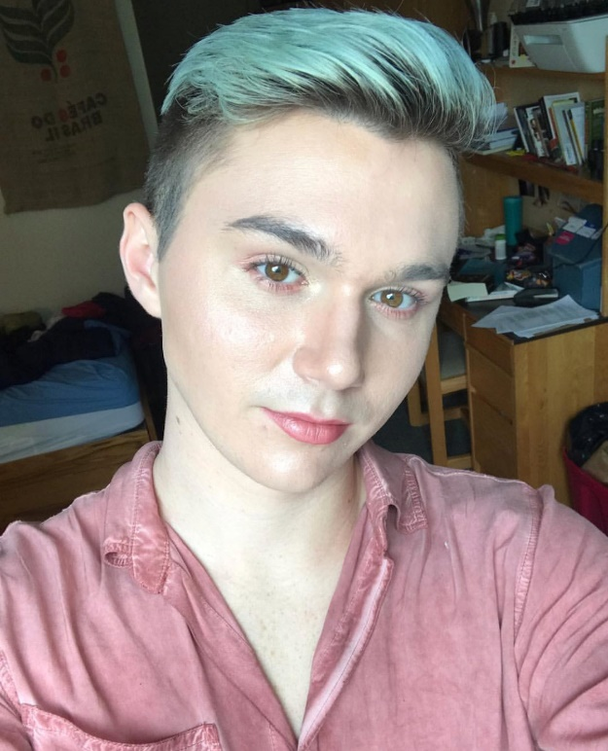
Michael is a sophomore Special Education/Women, Gender & Sexuality Studies double major at TCNJ. They are an academic and student life mentor.

“I am thankful for all of the experience and insight being a part of the CCS team has brought me. I am extremely excited to be helping and learning in a non-academic setting! “

Meet Jaclyn Kephart

Jaclyn is a TCNJ freshman pursuing degrees in Special Education and English. She works as a House Mentor Assistant.

“I absolutely love being involved with the CCS program! I have been getting involved as much as possible even though I have only been at TCNJ for a short time. Working with the students in Study Labs is a great experience, and being a part of Best Buddies has been the highlight of my time at TCNJ so far. I look forward to all of the great times ahead! I am so excited to begin working as a House Mentor Assistant.”

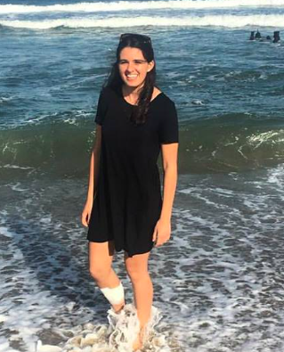
Meet Jenn Barbera

Jenn graduated last year with her bachelors in Psychology, and will be completing her Masters Degree in Special Education this year! This will be her second year as Student Life mentor for the Divas, Shanaya, Lexi and Nicole!

“I started out as an academic mentor when I was a freshman, and being a mentor was the reason I switched my major to Special Education after freshman year! Since then, I have worked as a vocational mentor, as well as a house mentor assistant before being a house mentor. I can’t believe it’s my last year as a mentor, but I can’t imagine spending my last year doing anything other than having another great year with my awesome housemates

Meet Jeremy Conover

Jeremy is a TCNJ sophomore Special Education and iSTEM major. He is a House Mentor Assistant for The Awesome House with Emily, Melissa, Courtney, Mike, and Alex.
“In the fall, I started volunteering for the CCS Program as an Academic Mentor, and was able to work as an Academic, Vocational, and Student Life Mentor in the spring. I cannot wait to continue with these roles this year. I always have an awesome time with all of the wonderful students, whether it be while working on a paper in lab, eating a meal at Eickhoff, or playing some sports outside! I have had such a great experiences with CCS last year, and cannot wait to have many more my next four years at TCNJ!” – Jeremy

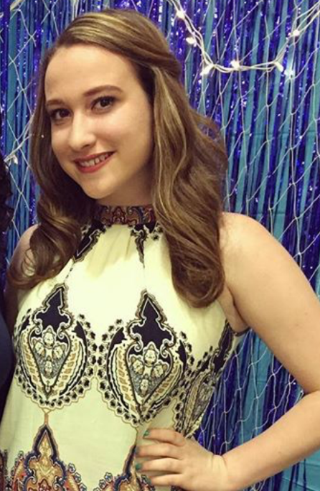
Meet Kelly Roche
Kelly is a sophomore at TCNJ, studying Early Childhood Special Education and iSTEM. She is an academic, vocational and social mentor for the CCS program.
“During my fall semester of freshman year, I had the honor of being in an FSP course called The Art and Study of Peer Mentorship with Professor Bonfanti. As part of my CEL, I had to pair up with one of the CCS students. We would meet two times a week. This was my first experience with the CCS program. I loved it. After this, I began to volunteer for the program until my second semester. Spring semester, I became an academic mentor and social mentor. Currently, I am an academic, vocational, and social mentor for the CCS program. I also mentor students with disabilities one on one, aside from the CCS program. I look forward to mentoring CCS students, with their independent living skills as well. This program has taught me many things, but most importantly has given me an abundance of new friendships.” –Kelly

Meet Natalie Zakroff

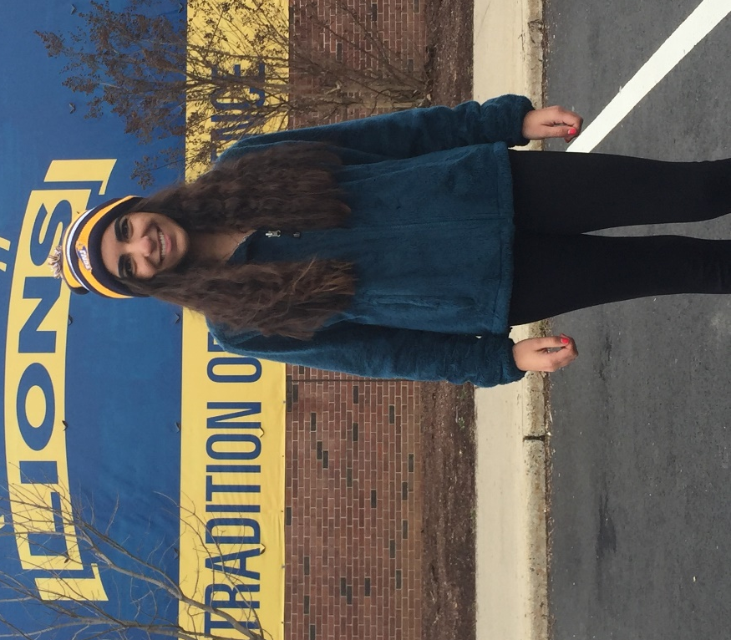
Natalie is a TCNJ Freshman and is pursuing her degree in Special/ Early Childhood Education and Spanish. She is a CCS study lab mentor, as well as a member of Best Buddies and Unified Sports.

“I have spent a lot of time with the CCS students during my first semester at TCNJ and have enjoyed every second of it. I look forward to forming more bonds with the students as my years go on. Being able to have more of a role in these students’ lives is a privilege that I am very thankful for. I am very excited for everything this semester will bring!”

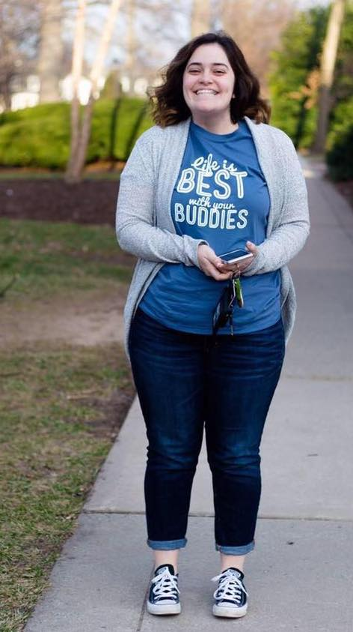
Meet Nicole Susino

Nicole is a TCNJ Junior working towards degrees in Special Education and Mathematics. She is the CCS Student Life Mentor for five freshmen: Brett, Peyton, Demetrios, Julia, and Jonathan.

“I have been working with the students in the CCS students since my freshmen year here at TCNJ. Getting to know the students in the academic and vocational settings was so fun, but I can’t wait to experience the independent living aspect! I am looking to a fun and successful year!”

Meet Santiago Yacovino

I am a TCNJ freshman Public Health major! I am also a new fitness mentor here at CCS.

“This is my first year working with the CCS Program, and I'm very excited to help the students learn and interact with them to the fullest, so I can learn from them as well.
I cannot wait to meet the students and learn about how dedicated and passionate they are! This community is perfect to help you strive for your goals, and I am glad I am part of it.” –Santiago

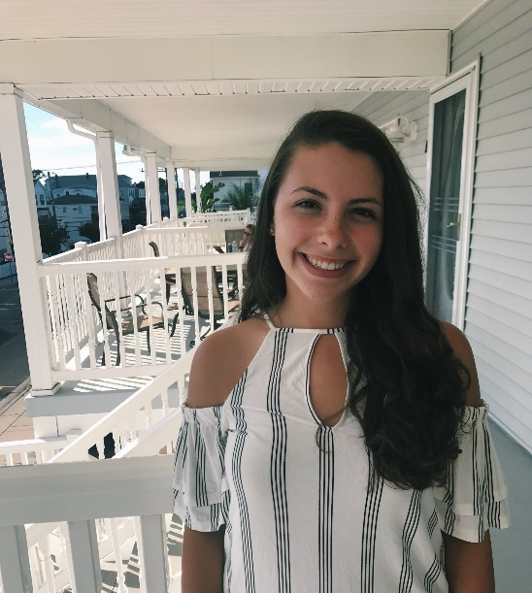
Meet Melissa Heintz

Melissa is a TCNJ junior working towards degrees in Special Education and Women and Gender Studies. She is the house mentor assistant for both freshman houses.

“I am going into my second year of mentoring for the CCS program, and I am the current President of Best Buddies at TCNJ! I have mentored academically, vocationally, and socially. I am looking forward to a fun and busy year with all of the students and staff in the program. I am taking on the role of “Lead House Mentor Assistant” in hopes to have my own house to mentor during my senior year!”

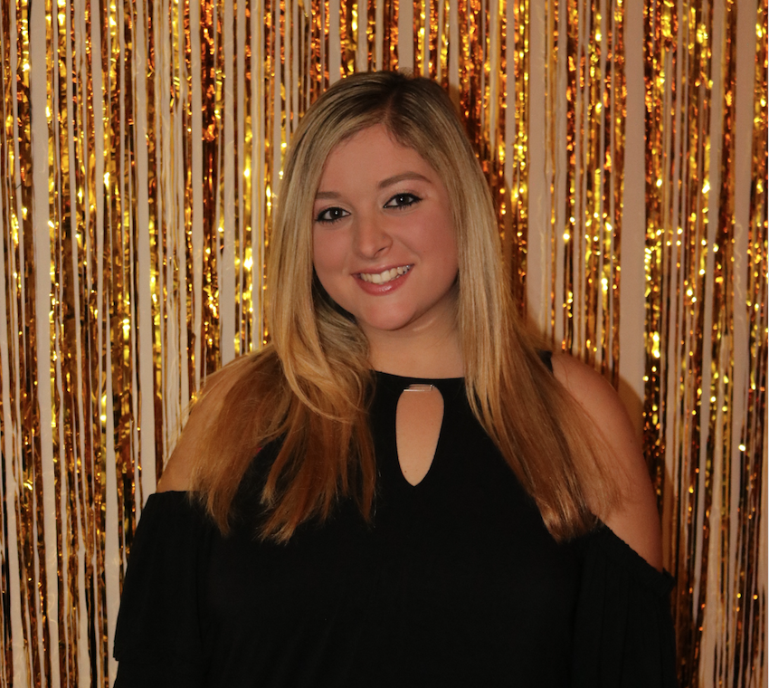
Meet Samantha LaMorte

Samantha is TCNJ Junior working towards degrees in Special Education and Sociology. In the past, she was an Academic and Vocational Mentor. Currently, she is an HMA and works in the CCS Office.
“I have been mentoring with the CCS program since the spring of my freshman year at TCNJ. The CCS program has provided me with so many wonderful experiences that I would not change for anything. I am excited to keep learning and growing in this program as well as continuing to meet new people and make friendships!”

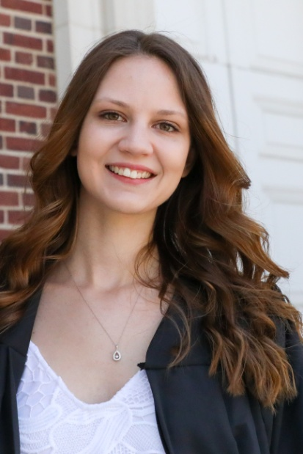
Meet Sarah Conger

Sarah is a TCNJ graduate student with her Bachelor’s Degree in English currently working towards her Master’s in Special Education. Her housemates are Ryan, Carl, David, and Zachary.

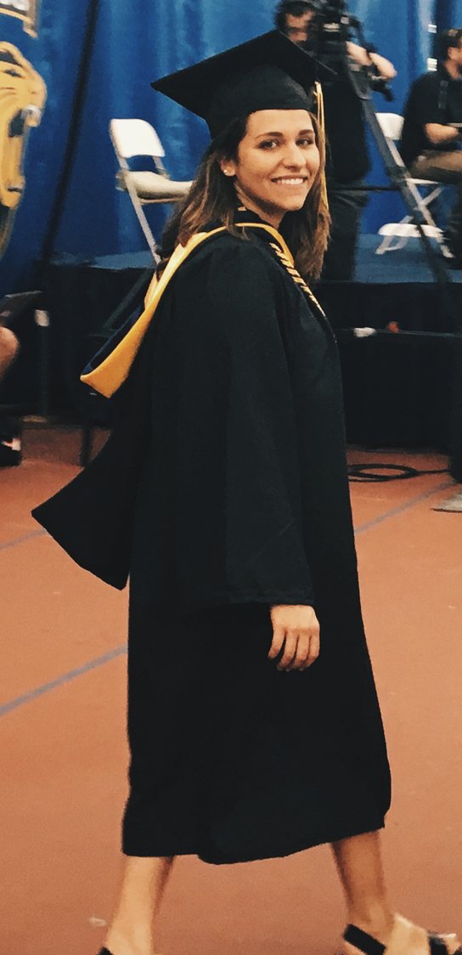
“I was welcomed into the CCS program by this year’s seniors when they were just beginning as freshman and now we are graduating together. Since then, I have gotten to know and love all of the CCS students as a vocational, academic and student life mentor. I love being able to learn and grow together while also making the best college memories! Even though it will be bitter-sweet, I’m so excited to have the best year yet with Ryan, Carl, Zach, David and all the CCS students and staff!” - Sarah

Meet Sophia Santo

Sophia is a TCNJ graduate student working towards her Master’s Degree in Special Education. She is the CCS Student Life mentor for five students in an on campus home.

“I have been a house mentor for the past two years and I am beyond thrilled to have the opportunity to spend my last year at TCNJ as a house mentor once again. My housemates have taught me more than I could imagine and all of us have grown immensely through this program. I am looking forward to the best year yet!” -Sophia

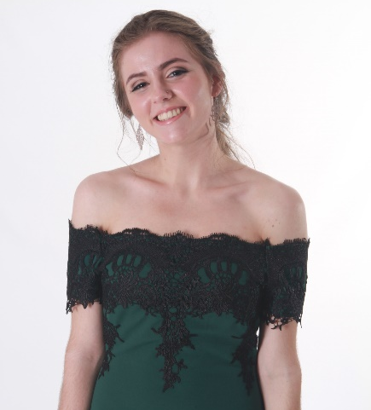
Meet Tessa Bragger
Tessa is a TCNJ undergraduate student working towards degrees in Early Childhood Special Education and iSTEM. She is a house mentor assistant and a study lab mentor.

“I found CCS through my friend who was already in the program when I was an incoming freshman. I decided to join because I volunteer back home, and I wanted to get involved on campus. Luckily, it was one of the best decisions I have made, and working with CCS never fails to put a smile on my face.” -Tessa

