Meet Amanda Beck!
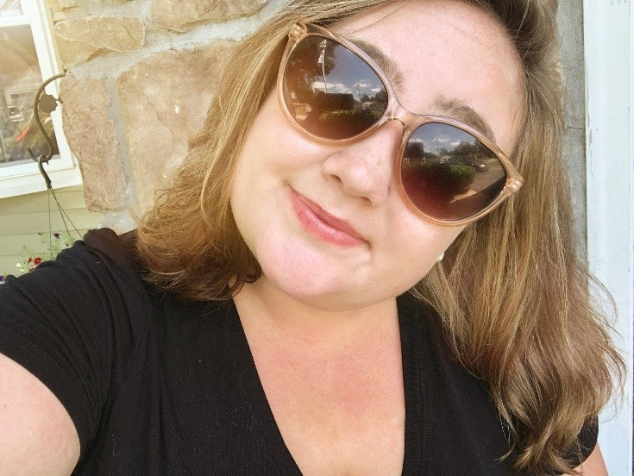
Amanda is a Senior in the 5-year Special Education program with a focus in Early Childhood and a second major in English. This is her third year as a House Mentor Assistant and fourth year as a CCS Academic and Vocational mentor. In addition to her studies and mentoring, she is the Co-President of SNJEA, member of Best Buddies, Kappa Delta Phi Education Honors Society, Sigma Tau Delta, serves as the Preservice Relations Chair for the New Jersey Education Association.

“I fell in love with the CCS program as soon as I heard about it on Accepted Student’s Day! I love getting to know all of the students on a personal level and having fun in and outside of the classroom! I am looking forward to another great year!”
– Amanda
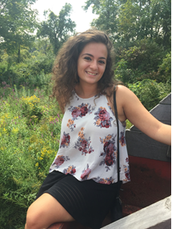
Meet Arianna Sirimis!
Arianna Sirimis is a fifth year at The College of New Jersey working towards a Master’s in Special Education. She is a returning CCS Student Life House Mentor for the upperclassmen!

“I have been working with the CCS program since my freshman year at TCNJ. I have supported students in the study labs, TCNJ classes, vocational placements, and as an HMA. All of my experiences have brought me joy, friendship, and knowledge! Extremely excited to start my second year as a House Mentor!” - Arianna
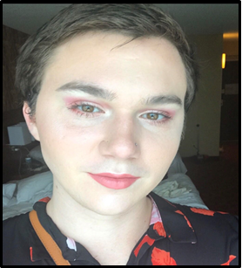
Meet Avery Madden!
Avery is a Senior working towards degrees in Special Education and Women, Gender, and Sexuality Studies. She is a House Mentor.

“I have been a mentor for the CCS Program since my freshman year. Mentoring has been one of the best experiences I’ve had at TCNJ. I am looking forward to another year of learning and excitement!”
- Avery

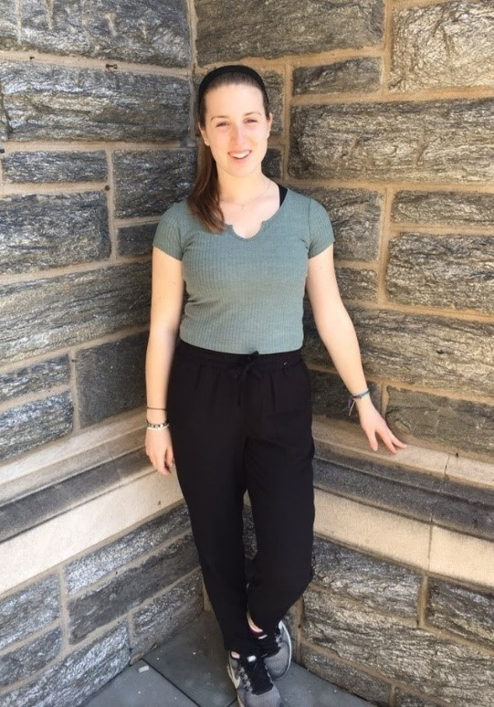
Meet Becky Raffin!
Becky is a TCNJ junior working towards degrees in Special Education and Music with a minor in Deaf Studies. Becky is the Vice President of Best and the VP of music for Catholic Campus Ministry. This is her third year working with the CCS program, and she is excited to be a House Mentor for the first-year students.
“I am going into my third year as a CCS mentor, and I am so excited to be a House Mentor for the first-year students! This program is so valuable to both the students and mentors, and I’ve learned so much through my involvement. I’ve loved getting to know all of the students and staff involved in this program, and I am looking forward to a great year!”
-Becky

Meet Daphne Stanfield!
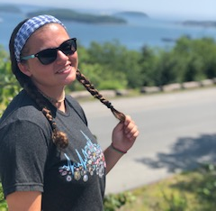
Daphne is a sophomore in the 5 year Special Education program with a focus in elementary mathematics. She has been an academic and vocational mentor in the past year. In addition to her studies and mentoring, she is the social chair for Best Buddies, historian of Unified Sports, and a member of Club Field Hockey. This is her first year as a House Mentor Assistant and she is looking forward to a great year!

“I have been a mentor for CCS since my first semester at TCNJ. It has been an incredible experience supporting such amazing students. I have been given a great opportunity to learn valuable life lessons and create unforgettable memories. Thank you CCS for being a huge part in my TCNJ experience!” - Daphne

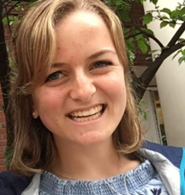
Meet Jaclyn Kephart
Jaclyn is a junior pursuing a degree in Special Education and English with a minor in Communication Disorders. She works as a House Mentor for first year students and has also worked as both an academic and vocational mentor. She is also the President of Best Buddies and the Secretary of Unified Sports
“I absolutely love being involved with the CCS program! I have had such amazing experiences getting involved in the academic, vocational, and student life aspects of the program. In addition, participating in Best Buddies and Unified Sports has been the highlight of my time at TCNJ! I am looking forward to a great first year of House Mentoring!” -Jaclyn
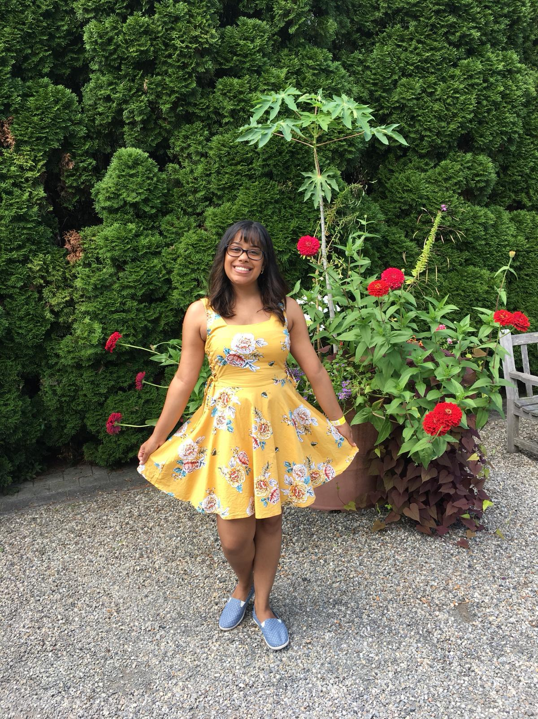
Meet Jenny Cuevas
Jenny is a sophomore EOF student in the school of the business with a specialization in Finance. She began working with the Career and Community Studies program her freshman year first semester. Other organizations of interest include the Economics Club and The Disability Pride Club.

“Weekly practicums have been the highlight of my week during the semester. It’s great to be able to work with my mentees and watch them grow!” -Jenny

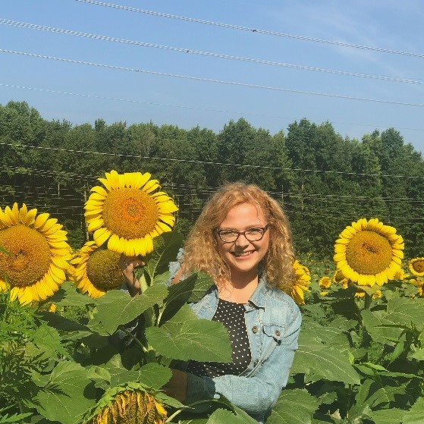
Meet Jess Soden
Jess is in her last year of the Special Education Master’s program. She has been both an academic and vocational mentor in the past four years. This is her second year as a house mentor for 62 Carlton Ave. She is the house mentor to Demetrios, Aaron, Katie, Katie and Samuel!
“Working with CCS has been my favorite part of my college experience. I’m so excited for another year of learning new things, making memories, and having a lot of fun!”
-Jess

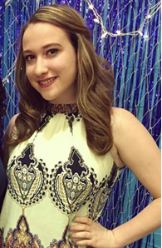
Meet Kelly Roche
Kelly is a senior in the 5-year Early Childhood Special Education and iSTEM. She is an academic, vocational and social mentor for the CCS program. This will be Kelly’s first year as a house mentor!
“During my fall semester of freshman year, I had the honor of being in an FSP course called The Art and Study of Peer Mentorship with Professor Demonte. I fell in love with my experience with the program so I began to volunteer for the program until I received the position of an academic mentor, vocational mentor, and a social mentor. Now I am proud to be a part of student life. I am a first-year house mentor and I am thrilled to be a part of this program. This program has taught me many things through the years, but most importantly has given me an abundance of new friendships.” –Kelly

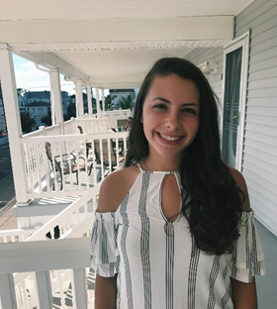
Meet Melissa Heintz
Melissa is a 5th year graduate student at The College of New Jersey, working towards her Master’s degree in Special Education. She is a returning house mentor for upperclassmen students.

“I am going into my fourth year of mentoring for the CCS program and have mentored academically, vocationally, and socially. I am looking forward to furthering my experience with independent living skills, and I am excited for a great year with my housemates!” -Melissa

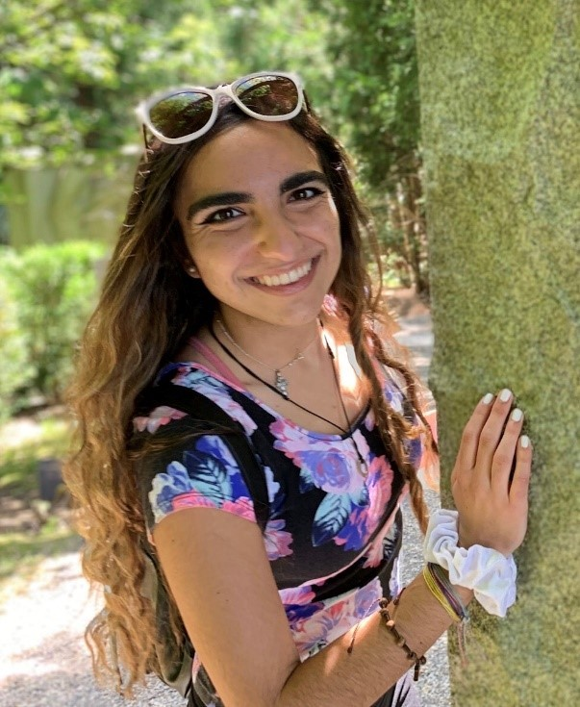
Meet Natalie Zakroff
Natalie is a junior studying Special/Early Childhood Education and Spanish. She has been a House Mentor Assistant for the past three semesters, taught a Spanish Independent Study and mentored in various Spanish classes. Besides being a CCS mentor, she is involved in TCNJ Unified Sports, Teachers of Young Children Association, Best Buddies, and Catholic Campus Ministry. This is her first year teaching Literature Study and she is so excited for the experience!
“The CCS Program has brought me so much joy over the past couple of years. From getting to make memories with the students to supporting them with their classes or in their houses, this program has changed my college experience. I cannot wait to see what this next year brings!”- Natalie

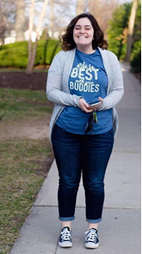
Meet Nicole Susino
Nicole is a TCNJ 5th year student working towards her Master's degree in Special Education. This is her third year being a house mentor for the CCS program. She is the CCS Student Life Mentor for a mix of six upperclassmen: Peyton, Kate, Julia M, Matthew, Derrick, and Jonathan..
“I have been working with the students in the CCS program since my freshman year here at TCNJ. Getting to know the students in the academic and vocational settings was so fun, but I can’t wait to further my experiences in the Student Life area! I am looking forward to a fun and successful year!” -Nicole

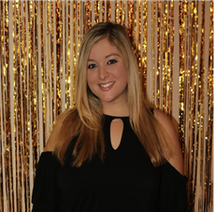
Meet Samantha LaMorte!
Samantha is TCNJ Graduate Student working toward her Masters Degree in Special Education. In the past, she was an Academic and Vocational Mentor. She also was a student worker in the CCS Office. This is her third semester as a House Mentor Assistant.
“I have been mentoring with the CCS program since the spring of my freshman year at TCNJ. The CCS program has provided me with so many wonderful experiences that I am extremely grateful for. I am excited to keep learning and growing in this program. I truly enjoy meeting new people and making lasting friendships!” - Samantha

