Career and Community Studies Program 2020 Summer Honors Program Historical and Modern Day Perspectives “Across the Pond” May 28 - June 25, 2020
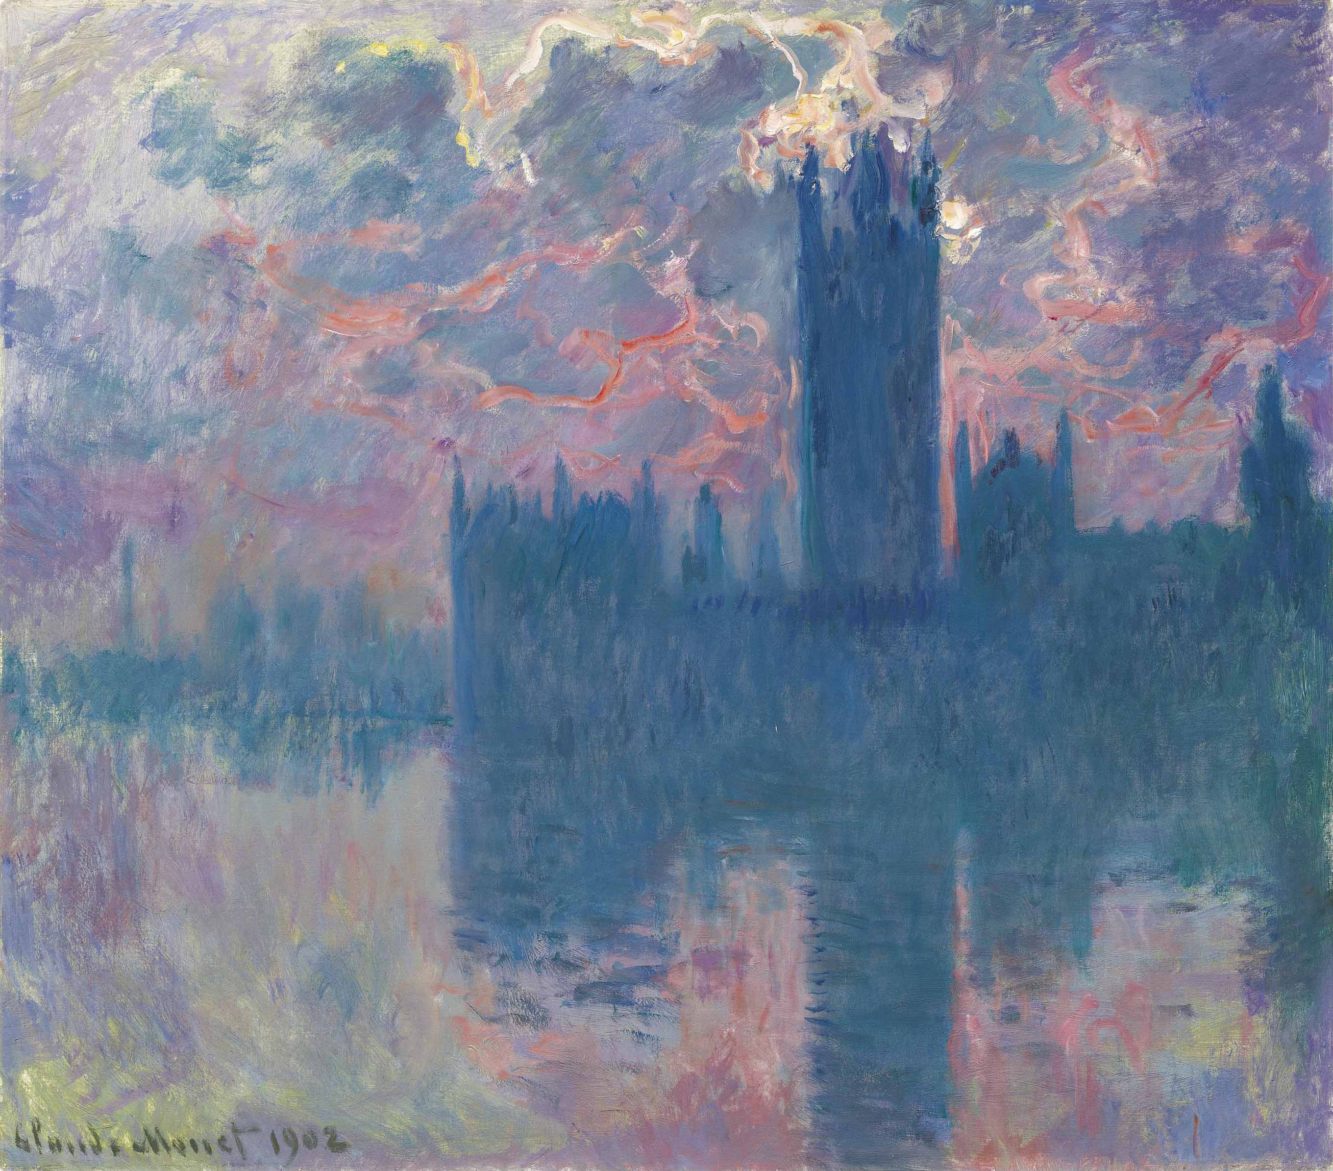
The 2020 CCS Summer Honors Program has been designed to provide an overview of the United Kingdom from a cultural, social and political perspective. During the on campus course of study, students will examine these areas with respect to domestic and foreign influences. This will be achieved through a three class course of study and a community engagement experience.*
The 2020 Summer Program will cumulate with a one-week faculty/staff led trip to London, England (6/17- 6/24). During the study abroad, students will apply and enhance their knowledge through experiential learning. Excursions will explore the juxtaposition of this country’s past and current views with respect to their customs and global relations. Students will be responsible for incorporating elements of study throughout their travel through reflective journaling and whole group discussions.
Participants: A limited number of rising sophomore-fifth year CCS Students will be accepted to attend this program through an application process. Successful completion will result in an honor cord to be worn during graduation (2020 graduating seniors would receive a cord for May 2020 graduation ceremony.)

Residential: Students attending the summer program will be provided with on campus housing as part of the session cost. The mentor/student ratio will follow CCS student parameters.

Session Cost: $ 6,032.00. This cost includes the following on campus elements: academic courses, supplies, day trips and housing (as noted below.) This cost includes the following trip related elements: lodging (double/triple), breakfast, UK ground transfers, insurance and select activities (to be confirmed.) This cost does not include on campus: meals, incidentals, and social activities. This cost does not include trip: US airport transfer, lunch/dinner/snacks, select trip activities, passport fee and incidentals.

Information Call: A general informational conference call will be held on December 23 at 5 pm. An email invitation will be sent to all students/families, an RSVP will be required for dial in details.

Application: Application will open 11/1/19. Please submit to CCS@TCNJ.EDU no later than December 1, 2019
Admission Decisions (via email) no later than: January 1, 2020

SUN | MON | TUE | WED | THUR | FRI | SAT
Home | 5/2 Home- Move in PM/Campus | 5/26  Campus/Courses | 5/27  Campus/Courses | 5/28  Campus/Courses | 5/29  Campus/Courses Move Out/Home | 5/30 Home
5/31 Home- Move in PM/Campus | 6/1  Campus/Courses | 6/2  Campus/Courses | 6/3  Campus/Courses | 6/4  Campus/Courses Move out | 6/5 Home | 6/6 Home
6/7 Home- Move in PM/Campus | 6/8 Campus/Courses | 6/9  Campus/Courses | 6/10  Campus/Courses | 6/11  Campus/Courses | 6/12  Campus/Courses | 6/13 Campus/Activity Move Out/Home
6/14 Home | 6/15 Home | 6/16 Home | 6/17 Experiential Learning/London  Departure | 6/18  Experiential Learning/London | 6/19  Experiential Learning/London | 6/20  Experiential Learning/London
6/21  Experiential Learning/London | 6/22  Experiential Learning/London | 6/23  Experiential Learning/London | 6/24  Experiential Learning/London  Return
INTEREST SURVEY: To help us arrange travel/excursions we would appreciate if you would click on the following link if you are interested in applying: https://tcnj.co1.qualtrics.com/jfe/form/SV_3UGn4QkDT8GpAhf

* Course information will be provided in spring term.

